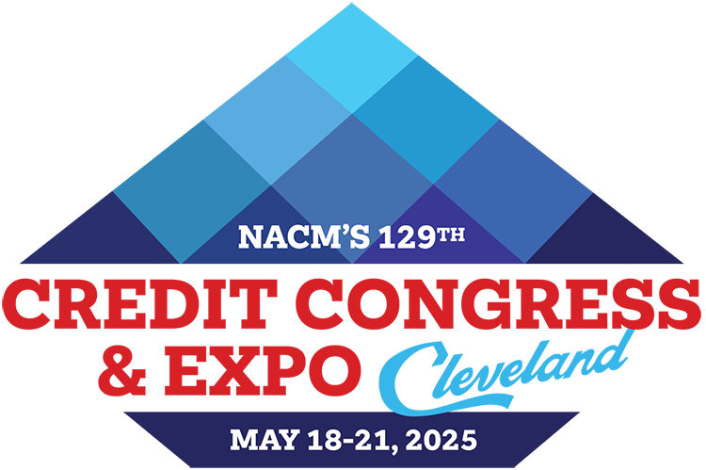
2025 NACM Credit Congress
Full Delegate Registration Form
Return form & payment to: NACM Credit Congress, 8840 Columbia 100 Parkway, Columbia, MD 21045
Address questions to: NACM Meetings Department / 410-740-5560 / conventions_info@nacm.org

Delegate Information
First Name or Nickname (for badge)
Full Name for Badge
(include professional designation)
Title
Company
(please provide complete name)
Mailing Address
(please include mail stop, floor, etc.)
City, State/Province, Zip/Postal Code
Country | My country of citizenship requires GDPR compliance.
Office/direct Phone Number
Cell Number | For emergency notices and limited text updates or important conference info.
E-mail Address

Your e-mail address is used to communicate with you. By providing this information to NACM, you are giving your written permission
to receive news updates and announcements regarding events, special offers and other information. You may opt out at any time.

Your Local NACM Affiliated Association (ex.–NACM Southwest):
Describe any special needs, such as dietary or wheelchair access:
Please indicate your company’s primary industry:

 |  |  |  |  | Total
 | Early Bird  12/6/24 | Advance  12/7/24 to 2/21/25 |  | Regular  after 2/21/25
Member * | $849 | $979 |  | $1,089
Non-member * | $1,049 | $1,149 |  | $1,249
Service Provider * | $1,359 | $1,459 |  | $1,559
First-time Attendee - Come with a Colleague **  (provide details at the bottom of this form) | $249 | $299 |  | $349
Spouse/Guest *  (provide details at the bottom of this form) | $479 | $519 |  | $579
Conference Rates & Optional Event Costs

Fees for the following are in addition to the registration fee. | Quantity | Rate | Sub-totals
Optional Educational Sessions and Luncheons:
Leadership Workshop Bundle (Tues, May 20 & Wed, May 21) | $99 Savings with Bundle | $399 | $
Change Leadership Workshop (Full day Tues, May 20) |  | $249 | $
Intergenerational Leadership Workshop (Full day Wed, May 21) |  | $249 | $
Business Credit Principles Certificate Course (Sat thru Wed) |  | $429 | $
Financial Statement Analysis 2 Certificate Course (Sat thru Wed) |  | $429 | $
CBA Exam Review Session (Sun, May 18) |  | $189 | $
CBF Exam Review Session (Sun, May 18) |  | $189 | $
CCE Exam Review (Sun, May 18 - includes box lunch) |  | $239 | $
CFDD Luncheon (Wed, May 21) |  | $89 | $
Additional Closing Night Event Ticket  (1 ticket included with Full Delegate registration) |  | $199 | $
I am proud to support the NACM Scholarship Foundation. | $10 $25 $50  $100 |  | $
I am proud to support the CFDD Scholarship Fund. | $10 $25 $50  $100 |  | $
Facilities Usage Fee ~ Applicable only if you are not staying at our conference hotel. |  | $250 | $
Total (required for processing): (NACM Tax ID# 52-1972771) |  |  | $

Payment Information My check is enclosed payable to NACM Credit Congress.
Both the form and payment must be received for the registration to be processed. Fees may be paid with a check with this form or credit card by registering online.

Refund & Cancellation Policy for Credit Congress - NACM understands that unfortunate circumstances may sometimes affect your ability to attend an event. Should a request for a refund be necessary, please submit your request to the NACM Meetings Department in writing. For written requests received on or before March 21, 2025, full registration fees will be refunded, less a $75 processing fee. Between March 22, 2025 to March 28, 2025, 50% of the registration fee will be refunded. Due to the financial obligations incurred by the NACM Credit Congress, NO REFUNDS OR CREDITS are possible for cancellations received after March 28, 2025; however, replacements may be made at any time.
Facilities Usage Fee - We urge you to make your hotel reservation at one of our three official conference hotels for NACM to maximize its meeting space, room block and help keep negotiated room rates as low as possible. The guest room block and group rate negotiated with the hotels includes costs to provide us with the large quantity of meeting spaces we require for the meeting. If we do not occupy a sufficient amount of guest rooms throughout the conference, we will incur penalties and additional costs. Therefore, we urge all meeting participants to stay in the host hotels. Consequently, guests not staying at one of the official host hotels during the conference will be charged a Facilities Usage Fee, a flat fee of $250, to offset penalties and fees. Please note: If your residential address is in Cleveland, Ohio, you are exempt from the Facilities Usage Fee stated above.
2025 NACM Credit Congress Registration Form - Page 2
Additional Information
If you are registering a First-time Attendee or a spouse/guest, complete the appropriate section below.

Required Spouse/Guest Information (may not be a colleague)

First Name or Nickname (for badge)
Full Name for Badge
City, State/Province
Cell Number | For emergency notices and limited text updates or important conference info.
E-mail Address

Required First-time Attendee – Come with a Colleague Information
(info of colleague accompanying the full delegate registrant, paying together)

First Name or Nickname (for badge)
Full Name for Badge
(include professional designation)
Title
Company
(please provide complete name)
Mailing Address
(please include mail stop, floor, etc.)
City, State/Province, Zip/Postal Code
Country | My country of citizenship requires GDPR compliance.
Office/direct Phone Number
Cell Number | For emergency notices and limited text updates or important conference info.
E-mail Address

** First-time Attendee – Come with a Colleague
This special offer is for credit practitioners who have never attended Credit Congress and who will attend with a member or nonmember full delegate from the same company. Both delegates must have an individual room reservation at one of our three official hotels (see housing page) during the conference. Housing will be verified through our housing block. Offer is not valid with the Teams, Service Provider or Guest rates and cannot be combined with other offers, discounts or scholarships. Only one first-time attendee registration is permitted per each full delegate registration. Should the full delegate cancel, the first-time attendee will replace the full delegate registration at that rate. Should the new attendee cancel, the registration fee is nonrefundable.

2025 NACM Credit Congress Registration Form - Page 3

