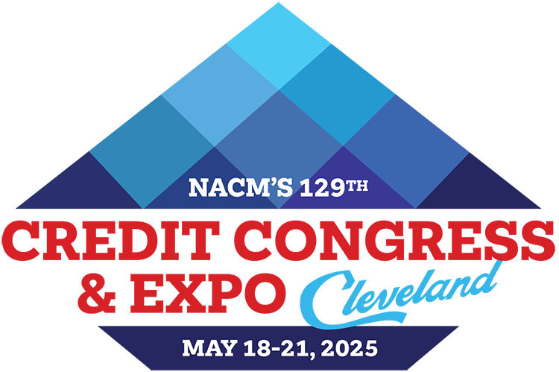
2025 NACM Credit Congress
Full Delegate Registration Form – Affiliate Staff
Return form & payment to: NACM Credit Congress, 8840 Columbia 100 Parkway, Columbia, MD 21045
Address questions to: NACM Meetings Department / 410-740-5560 / conventions_info@nacm.org

Delegate Information
First Name or Nickname (for badge)
Full Name for Badge
(include professional designation)
Title
Company
(please provide complete name)
Mailing Address
(please include mail stop, floor, etc.)
City, State/Province, Zip/Postal Code
Country | My country of citizenship requires GDPR compliance.
Office/direct Phone Number
Cell Number | For emergency notices and limited text updates or important conference info.
E-mail Address

Your e-mail address is used to communicate with you. By providing this information to NACM, you are giving your written permission
to receive news updates and announcements regarding events, special offers and other information. You may opt out at any time.

Your Local NACM Affiliated Association (ex.–NACM Southwest):
Describe any special needs, such as dietary or wheelchair access:
Please indicate your company’s primary industry:

 |  |  |  |  | Total
 | Early Bird  12/6/24 | Advanced  12/7/24 to 2/21/25 |  | Regular  after 2/21/25
Affiliate Staff Rate | $495 | $495 |  | $495 |  | $
Spouse/Guest | $479 | $519 |  | $579 |  | $
Conference Rates & Optional Event Costs

Fees for the following are in addition to the registration fee. | Quantity | Rate | Sub-totals
Optional Educational Sessions and Luncheons:
Leadership Workshop Bundle (Tues, May 20 & Wed, May 21) | $99 Savings with Bundle | $399 | $
Change Leadership Workshop (Full day Tues, May 20) |  | $249 | $
Intergenerational Leadership Workshop (Full day Wed, May 21) |  | $249 | $
Business Credit Principles Certificate Course (Sat thru Wed) |  | $429 | $
Financial Statement Analysis 2 Certificate Course (Sat thru Wed) |  | $429 | $
CBA Exam Review Session (Sun, May 18) |  | $189 | $
CBF Exam Review Session (Sun, May 18) |  | $189 | $
CCE Exam Review (Sun, May 18 - includes box lunch) |  | $239 | $
CFDD Luncheon (Wed, May 21) |  | $89 | $
Additional Closing Night Event Ticket  (1 ticket included with Full Delegate registration) |  | $199 | $
I am proud to support the CFDD Scholarship Fund. | $10 $25 $50  $100 |  | $
I am proud to support the NACM Scholarship Foundation. | $10 $25 $50  $100 |  | $
Facilities Usage Fee ~ Applicable only if you are not staying at our conference hotel. |  | $250 | $
Total (required for processing): (NACM Tax ID# 52-1972771) |  |  | $

Payment Information
Both the form and payment must be received for the registration to be processed in full. Fees may be paid with a check with this form or credit card online after submitting the form electronically.

Check enclosed payable to NACM Credit Congress OR Send me a web link to pay by credit card to complete my registration

Refund & Cancellation Policy for Credit Congress - NACM understands that unfortunate circumstances may sometimes affect your ability to attend an event. Should a request for a refund be necessary, please submit your request to the NACM Meetings Department in writing. For written requests received on or before March 21, 2025, full registration fees will be refunded, less a $75 processing fee. Between March 22, 2025 to March 28, 2025, 50% of the registration fee will be refunded. Due to the financial obligations incurred by the NACM Credit Congress, NO REFUNDS OR CREDITS are possible for cancellations received after March 28, 2025; however, replacements may be made at any time.

Facilities Usage Fee - We urge you to make your hotel reservation at one of our three official conference hotels for NACM to maximize its meeting space, room block and help keep negotiated room rates as low as possible. The guest room block and group rate negotiated with the hotels includes costs to provide us with the large quantity of meeting spaces we require for the meeting. If we do not occupy a sufficient amount of guest rooms throughout the conference, we will incur penalties and additional costs. Therefore, we urge all meeting participants to stay in the host hotels. Consequently, guests not staying at one of the official host hotels during the conference will be charged a Facilities Usage Fee, a flat fee of $250, to offset penalties and fees. Please note: If your residential address is in Cleveland, Ohio, you are exempt from the Facilities Usage Fee stated above.
2025 NACM Credit Congress Registration Form – Aff Staff - Page 2

